Every Pitch…Even a Fastball…Has an Arc

by Gerald Warner, Softball Pitching Instructor


No pitch...not even the fastest fastball...is thrown on an absolutely level line. All pitches, regardless of how fast they are thrown, have an "arc" in them. And, as you can see below, change-ups and other off-speed pitches can have quite a dramatic arc.
It's gravity that pulls the ball toward the ground no matter how fast they are thrown forward. If you are a student of physics you might know that the up and down curved path that the ball takes is called a "parabolic arc". Since gravity's downward pull remains constant, the height of this arc depends largely on: (1) the speed (velocity) that the ball is thrown, (2) the distance that the ball will travel, (3) the angle at which the ball is release, and (4) wind resistance.

Although these factors are meaningful for EVERY pitch, the three pitches that are most directly affected by this arc are:
FAST BALL - As you can see below, even though a 60 mph fastball seems like it is coming in on a pretty level line, it goes up...then down...as much as 8 inches in the time that it takes to get from the pitcher's hand to the plate.
RISE BALL - We mentioned in another section of this website that a rise ball needs to be thrown in the low to mid-50's before the backwards spin can have enough effect to actually make the ball go UP. In the diagram below, you can see that a rise, even thrown at 60 mph has to have enough spin to overcome an 8-inch gravity-induced arc...JUST TO LEVEL OUT! The release and speed of the spin has to be even better to make it hop over the bat.
CHANGE-UP - We have seen a majority of pitchers throwing their change-up too fast, because they (or their coach) wanted the ball to come in on a level line. Obviously, we do NOT advocate a huge arc on a change-up (that's what slow-pitch softball pitching is all about). As we mentioned in another part of this website, we work with pitchers to (1) make the change-up LOOK deceptive, and (2) to come in at a speed 25% to 35% slower than their fastball. That means that a younger pitcher with a 50 mph fastball would want a change-up of about 35 mph or so. A 55 to 58 mph fastballer works well with a 40 mph change-up.
In the example shown below, a pitcher wanting to throw a 35 mph change-up should try to throw it so the highest point of the pitch is about equal to the level of her shoulders.
A pitcher with a 40 mph change would see the top of the arc about chest high.

Every Pitch Has an Arc (p. 2)

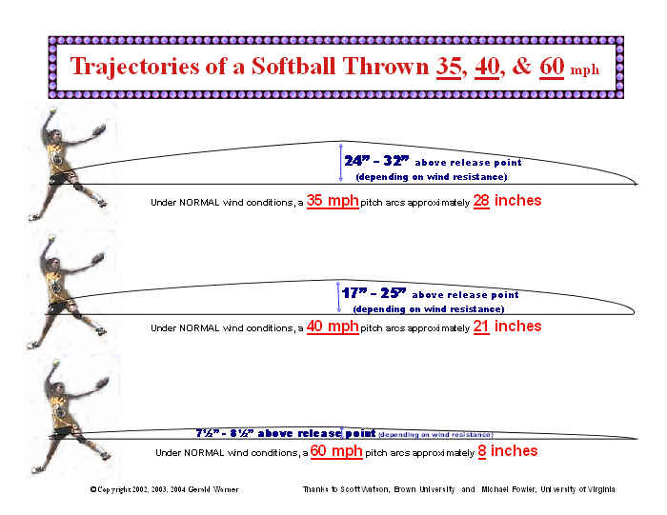
Since wind resistance is a factor, remember that if the wind is coming in from the pitcher's back (blowing toward home plate) the ball will be more level that the above diagrams show. If the wind is blowing in from the catcher's back, the ball has to be thrown faster or needs more of an arc to reach the target.

If you have questions or need more information, E-mail us at: gw@pitchsoftball.com or call us in Colorado at (720) 200-4575

